Time-Series Data
Assignment-3
BA-64061-001 Advanced Machine Learning
Chaojiang (CJ) Wu, Ph.D.

Sreeja Reddy Kaithi
skaithi@kent.edu
Student ID: 811327770

Introduction:
Once we finish this temperature prediction activity, we’ll clearly see how time-series data is different from the other dataset types we’ve studied so far. You’ll see that this kind of network doesn’t work well for convolutional models that are tightly connected. But with a new machine-learning method called RNNs, these problems can be handled much more effectively.

Splitting the data:
In each study, we divide the data into three parts: training gets 50%, validation gets 25%, and testing uses the remaining 25%. Validation and test sets in time-series work should be big enough, because we’re trying to predict what comes next from past data, not explain the past using the future. More up-to-date than the data used to train. Validation and testing should consider this difference. So here’s the real challenge: using just one set of hourly readings from the previous five days, can we accurately forecast the temperature at any time during the next day?

Methods:
- Basic Dense layer:
Before setting up the neural network, they first cleaned and prepared the data through preprocessing. We had the data in numbers, so we skipped vectorization. The study then tested 14 models for time-series analysis. Our baseline model got a mean absolute error (MAE) of 2.64, so we used that as our reference point. Then we built a simple machine learning model by adding a densely connected thick layer. Using this method made things worse, the MAE was 2.64. The main issue hurting performance was data flattening, which erased key time patterns from the time series. Most validation scores improved, but this method sometimes helped slightly without actually learning anything new.

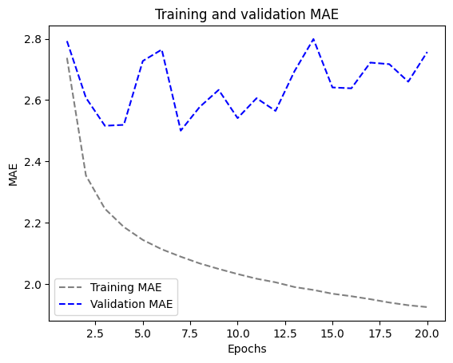

- 1D convolutional model:
When input data follows daily patterns, convolutional models fit well, because they use built-in design choices made for time series analysis. Temporal convolutional networks work like image convolutions: they reuse the same filters across time to spot patterns from one day to the next. TCNs can spot repeating patterns over time by learning shared features, which is why they fit this task well. When we put the convolutional model into practice, it didn’t meet the target performance. Packed model results were not as good as both other models, with validation MAE 3.39 degrees higher. The convolutional model didn’t perform well, partly because the weather data didn’t stay consistent when shifted, even though translation invariance is a core idea behind this kind of architecture. The convolutional model hit its highest validation error at 3.39 MAE, beating both the baseline and the predicted results.

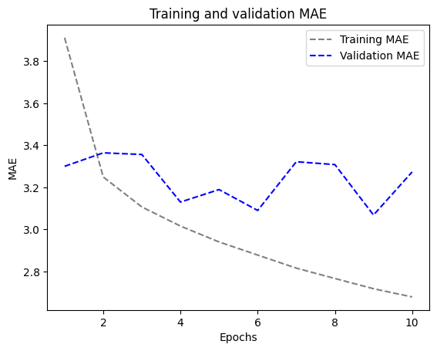
- A Simple RNN:
Recurrent neural networks are great at using past time-step information to guide decisions now, helping you find complex patterns and connections in data that comes in sequence. An RNN keeps what it has seen before in its internal state, so it can explain sequences of different lengths. Even if a basic RNN can, in theory, remember everything from earlier times, real-world problems still show up. That’s what triggers the vanishing gradient problem, making it harder to train deep neural networks. The graph makes it clear that the simplest RNN does worse than all the others.

To overcome this problem, as a part of Keras, we have to create LSTM and GRU RNNs.

GRU:
We’ll use GRU layers instead of LSTM layers. GRUs are closely related to LSTMs, think of them as a simpler, more compact version of the LSTM design.

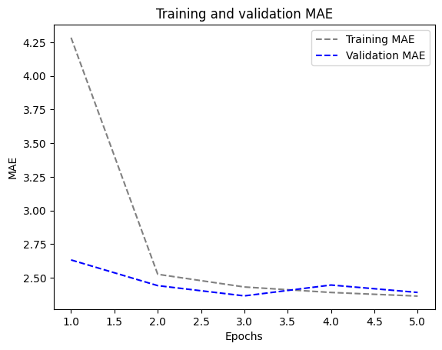
The MAE model with 3.5 is the most efficient choice since it costs less computational power than the other LSTM models. It also handles long-range dependencies in order data well, better than other models.

LSTM
Recurrent neural networks were designed for this purpose, using a specific kind of neural network layout. An LSTM, short for Long Short-Term Memory, is one of the most commonly used techniques. After testing the LSTM layer, we'll check how these models work.

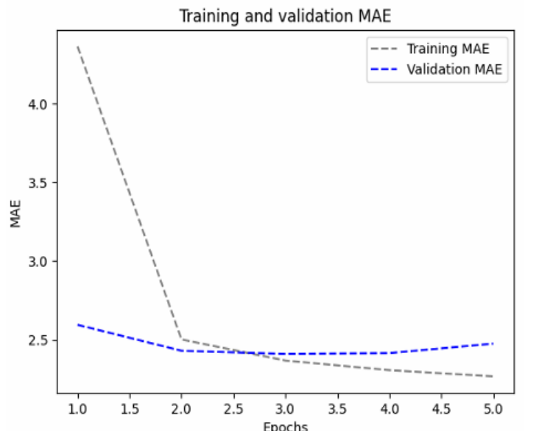

Much better! We get a validation MAE as low as 2.4 degrees and a test MAE of 2.62 degrees. Lastly, the LSTM-based model shows how effective machine learning is in this endeavour by outperforming the common-sense baseline (although only slightly, at least for the time being).

LSTM - dropout Regularization:
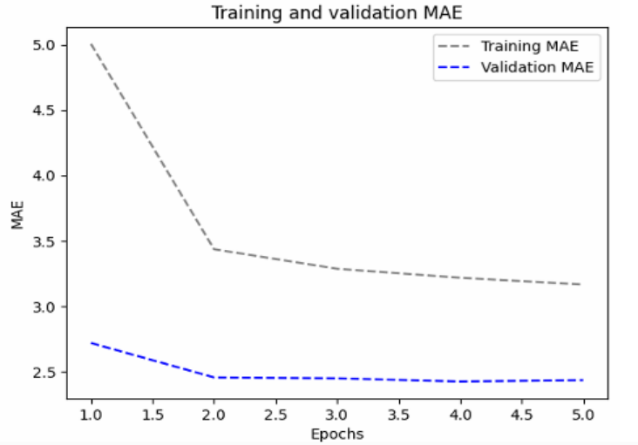

Achieved! After the initial five epochs, the overfitting has ceased. We achieve an MAE of 2.64 degrees for the test and 2.42 degrees for the validation Using 8, 16, and 32 units as varying numbers of units inside the stacked recurrent layers, I constructed six distinct LSTM models.

LSTM - Stacked setup with 8 units

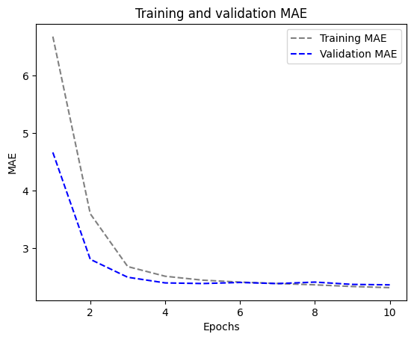

LSTM - Stacked setup with 16 units

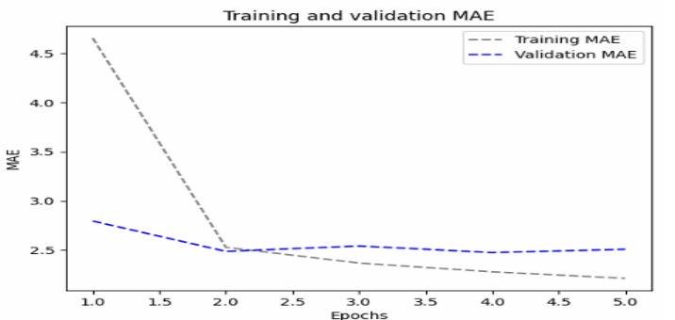

LSTM - Stacked setup with 32 units

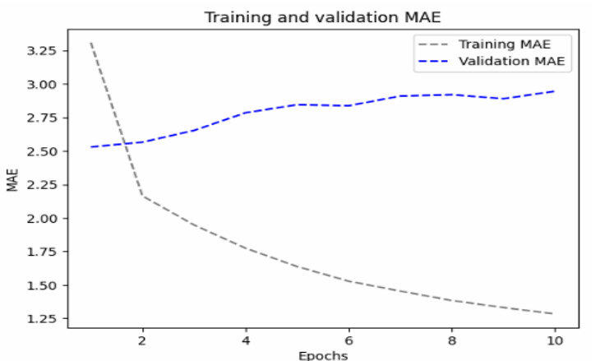

The eight-unit setup did best, scoring an MAE of 2.55. To avoid overfitting, I tried methods like recurrent dropout and bidirectional data, which help the recurrent network learn differently and, in turn, lower the MAE scores. Across every model, the upgrades brought similar MAE scores, and surprisingly, all of them were lower than the commonsense model’s. Even more surprising, the MAE graph backs up the same result.

LSTM - dropout-regularized, stacked model

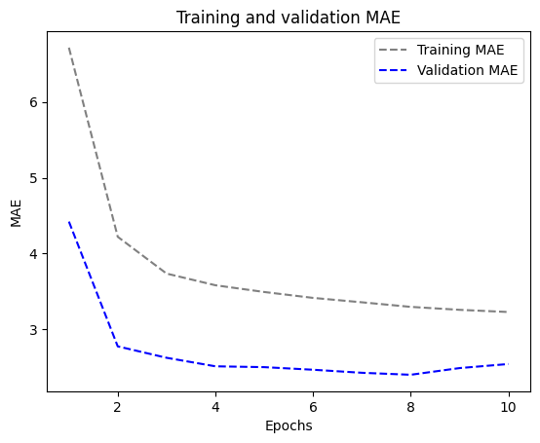

Bidirectional LSTM

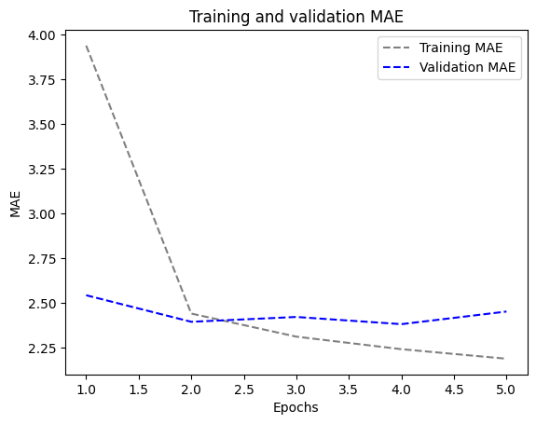

I built the model using a mix of RNNs and 1D convolutions with LSTM, but the 3.89 MAE score wasn’t great. The convolution limit might be why it performs so badly, because it scrambles the order of information.

